Bus Ticket Booking System
Project: QuickBus | Technology: HTML, CSS, JavaScript (localStorage)

Aim
To build an online bus ticket booking application with route search, seat selection and ticket generation.

Algorithm
- Start: load buses, routes and bookings from localStorage.
- User logs in and selects source, destination and date.
- Filter buses matching the route and show timing and fare.
- Draw the seat layout; mark already-booked seats as unavailable.
- User selects seats; total fare = seats × fare.
- Enter passenger details, confirm and save booking; generate ticket.
- Admin manages buses/routes and views bookings. Stop.

Result
The Bus Ticket Booking System was implemented successfully using HTML, CSS and JavaScript. All modules (login, role-based pages, data entry, search/booking and admin management) work correctly in the browser, and data persists using localStorage.

Implementation (Output Screenshots)
Home page
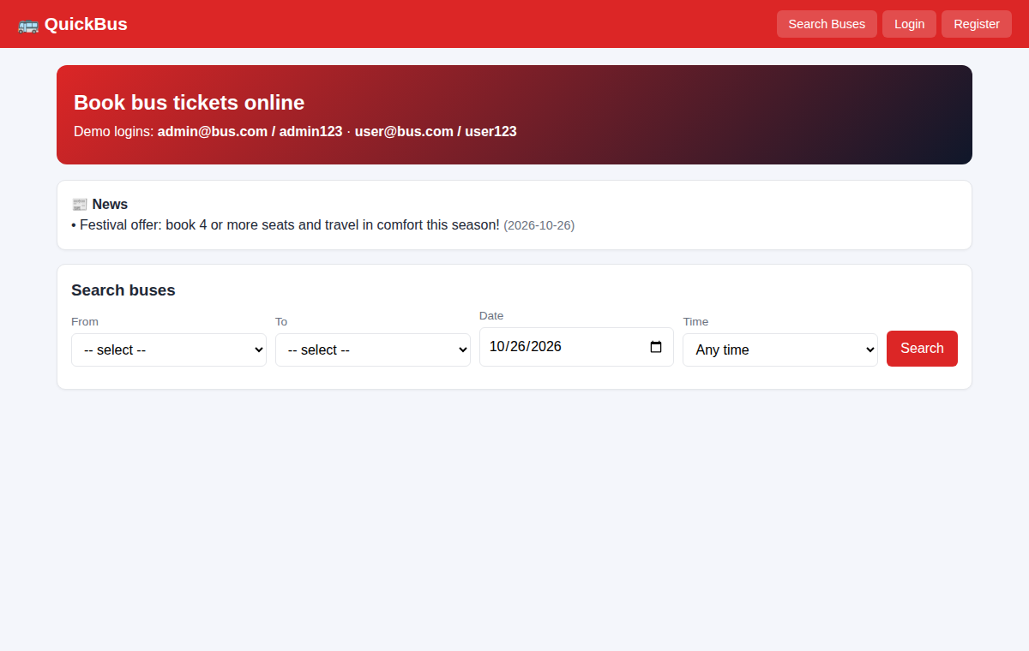
After login (admin / dashboard)
